

**Sales, Purchase & Production Management System for**

**"SAMPATH PRODUCTS"**

R. D. D. GANGANATH

BIT Registration No.: R210458

Index No: 2104581

Supervisor Name: Mr. A. H. P. Jayaweera

**March, 2023**

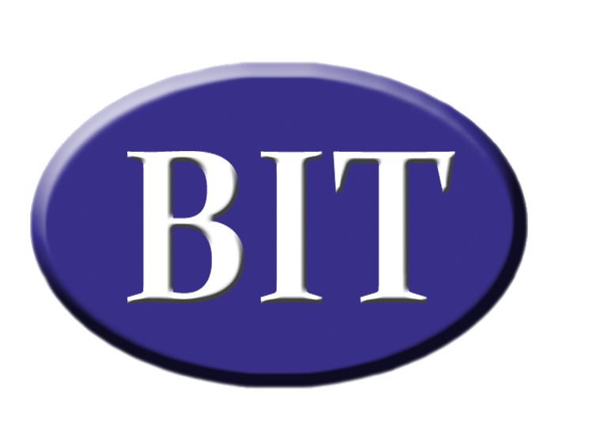



**This Interim Report is submitted in partial fulfilment of the requirement of the**

**Degree of Bachelor of Information Technology (External) of the**

**University of Colombo School of Computing**

# Abstract

**“Sampath Products”** is a company that manufactures and distributes packets of **Biscuit powder** on a small scale in the area. It manufactures and distributes packets of various sizes following its own methods by procuring the required raw materials from a **few selected suppliers**. The primary targets for this are small **retail businesses and wholesale businesses** in the area. These buyers and suppliers are permanently identified.

Currently, they are continuing their business process with themselves as manual process. That was an essential way to do a such a thing because at that time period, the business was much simpler and small scaled one, however now it is increasing day by day, need an efficient system to manage the system is a business need to them.

As the solution for this problem this system will be created. For creating this kind of system, the OOP based programming language and framework should be used and as the tool for developing this kind of software, simple and common tools should be used. To overcome this problem, **Spring Boot** framework is used to developing the system which is based **Java** programming language. As the developing tool, simpler and common **Visual Studio Code** has been used. For the database manipulating, **MySQL** database management system was created.

For the software development architecture very popular **MVC model** was used. For developing methodology, **Iterative and incremental method** should be used for this kind of software since the requirement are changed continuously.

This report will be discussed how this procedure is continuing as well as what are the strategies and design patterns used to create this.

# Table of Content

Abstract ii

Table of Content iii

Table of Figures iv

Chapter 1: Introduction 1

1.1 Motivation for project 1

1.2 Project Objectives 2

1.2.1 Privilege Management Sub - System 2

1.2.2 Supply Management Sub-System 2

1.2.3 Process Management Sub-System 2

1.2.4 Distribution and sales Management Sub-System 3

1.3 Scope of the Project 3

Chapter 2: Analysis 4

2.1 Requirement Gathering Process 4

2.2 Current Business Process of the Sampath Products 5

2.2.1 Supply Management Process 5

2.2.2 Production Management Process 6

2.2.3 Distribution and sales Management 6

2.3 Functional and Non – Functional Requirements 7

2.3.1 Functional Requirements 7

2.3.2 Non-Functional Requirements: 8

Chapter 3: Design of Solution 10

3.1 MVC Architecture 10

3.2 Iterative Method 11

3.3 UML diagrams 12

3.3.1 Class diagram 12

3.3.2 Sequence Diagram 14

3.3.3 Activity Diagram 15

3.3.4 Use case diagram 17

3.4 Wire Frame Diagrams 18

3.5 ER Diagram 21

Reference 27

# Table of Figures

Figure 1 MVC Architecture 10

Figure 2 Iterative Method 12

Figure 3 Class diagram for Sampath Products 13

Figure 4 Sequence Diagram for Sampath Products 14

Figure 5 Activity diagram Process Management Sub-system 15

Figure 6 Activity diagram Distribution and sales Management 15

Figure 7 Activity diagram Supply Management System 16

Figure 8 Use Case Diagram for Sampath Products 17

Figure 9 Table View 18

Figure 10 Context Menu 19

Figure 11 Message Box 20

Figure 12 ER diagram for Sampath Products 21

# Chapter 1: Introduction

## Motivation for project

Sampath Products, the biscuit powder company is currently being run completely manually. Due to the increase in the number of orders received and increase in demand, there is difficulty in store, handling data and information about the business. Basically, the following types of data can be identified in this business.

* Data and information about **suppliers and supply process**.
* Data and information related to the **manufacturing process**.
* Data and information on **product distribution and sales**.

Due to the increase in the number of orders that are increasing day by day and the fact that this procedure is almost completely manual and not automated, many problematic situations arise.

* **Lack of proper understanding of the quantities of raw materials required.**

With this problem, business faces related sub problems related this. When the orders manipulating, they have accepted much more customer orders over, they can be manipulated, because of understanding how much usable raw materials they have already with them. Then they would be failed to order a new bulk of materials at time.

* **Haven’t systematic way to order materials as soon as they wanted.**

Currently they have not any well managed and organized way to inform their suppliers how much raw materials they needed, as well as, by when they needed them. Sometimes they are purchasing the materials, from the wrong supplier without analyzing the quotation values with the other supplier as well.

* **Difficulty keeping track of leftover biscuit powders to pack.**

Because of this issue the company will loss money in various ways. When there is no any systematic way to batch handling and manipulating products, they will miss the recently expiring product batches as well as the will produce many more products even tough they have the already manufactured products.

To store and handle this data and information and to resolve these problems, it is expected to create a web application.

## Project Objectives

The aim of this project is to help the existing business activities, such as supplier management, manufacture and production management and customer and sales management of the business by giving correct and efficient answers to the weaknesses mentioned above. All the activities mentioned above are carried out by the following subsystem available in this system.

### Privilege Management Sub - System

The main objective of this project is to provide and manipulate the data and information on business activities. When these information and data properties are manipulated there are few roles are defined as the client’s requirements. So, mainly we can identify administrative people and sales representative people. So, in this system the security maintenance is very important and for that security needs, a logging system is maintained. So that, the transparency and accurateness of the data is increases. Then the reliability of the transaction will be increased.

### Supply Management Sub-System

This section mainly addresses the problems regarding the supplier management and raw material processes. Most problems are happened when ingredients are low to manufacture the products. So, there should be a method to indicate how much remaining raw materials are there in stores. User can identify and place an order to purchase materials when store is less than certain amount. Cost management and quotation management can be done with the system. Not only the raw material manipulating, but also this section can be used for maintaining supplier details. Quotation management also can be done by this.

### Process Management Sub-System

This section is created to manipulate the store details on the already manufactured products. Here we can get an understanding of the existing prepared biscuit powder and the number of packets of each size. These products are separated as the batches according to their manufactured date. Then we can know about the expiry dates of the currently remaining packets. Then wastage is decreasing. When manage the customer orders, it is easy to know about the total amount of packets required for orders and their quantity.

### Distribution and sales Management Sub-System

The system owned company has a clearly defined customer base. The products those manufactured by the business is sold to the small groceries and wholesale businesses. Those customer businesses are well defined. By this sub system the process on customer order note handling, taking notes on customer orders will be handled. Manipulating the customer details also one of the main objectives of this system. Information database of customer information will be managed under this system. This system keeps the records on information about the quantities of packets sold and the income.

## Scope of the Project

**Supply Management Sub-System**

* Supplier Management.
* Purchase Order Management
* Material Receive Note Management
* Material detail, Inventory Management
* Quotation Request Management.
* Supply Payment Management

**Production Management Sub-System**

* Material Analysis Management.
* Production Order Management.
* Product detail Management
* Inventory Management

**Distribution and sales Management Sub-System**

* Customer Management.
* Customer Order Management.
* Customer Invoice Management
* Delivery Management
* Payment Management

**Privilege Management Sub - System**

* User Management.
* Privilege Management.

# Chapter 2: Analysis

This chapter is written to describe the present process of the business, business requirements related to the client’s business and the non-functional requirements.



## Requirement Gathering Process

Since, Sampath Products is situated in the very closely, planning the requirement gathering procedure was become very easier. The client also provided much help for identifying the requirements accurately. Mainly this process handled by three ways.

**Interviews**

In this method, the client will be met face-to-face and discussed about the current process of the business is following. These meetings are conducted periodically. Each day, one of module is taken and how the process is currently happening. Suggestions of the users also collected from them. Suppling requirements on supplying mainly collected through this method. At the beginning this method was little bit harder to gather correct and accurate requirements, because of the difference and the gap of the knowledge on the Information Technology. Next two methods are used to maintain this problem.

**On-site Experiences**

When the requirements gathering, to get good idea on how the process is going in the business, on-site experience has been taken. Weekly, I joined with the visit to collect and buy the materials. After collecting I have joined with them to collect and get a knowledge about functional requirements on the process of manufacturing. With this procedure the knowledge gap of the developer has been reduced and it helps to get a proper understanding of the business.

**Prototype Method**

In this method, a prototype design was created and present to the users and validation is done with that. This one was the most successful method to collect the requirements. Periodically a prototype has been submitted to the client and get an idea on the current status of the system already developed and by that prototypes client can identify whether we have understood the requirements they have mentioned those they wanted.

## Current Business Process of the Sampath Products

Currently, the fully business process of this business is handled manually by the managers and the administrative panel of the Sampath Products. Business data and information flows into this business as follows.

### Supply Management Process

Under this process, all the management of material purchasing, material ordering supplier details handling, supplier order management and related activities are done.

**Materials**

Materials, those are used for the manufacturing is well defined because their main product is Bread Powder and Biscuit Powder. So, the ingredients, used for this process also clearly defined. There are three main types of ingredients can be identified.

* Dry bread
* Raw bread
* Bun

When purchasing the materials, the users are normally using a typical method to do that. Simply, periodically (weekly), they visit to the supplier’s places one by one to collect the materials. Before three (3) days, they are wishing to go to the suppliers, they should be informed. From one visit, few kilos about 10kg of basic ingredients can be collected. Prices will be based on the market price at that day.

**Suppliers**

Suppliers also well defined. Normally, they can be identified as some bakeries, groceries, retail sellers and whole sellers. Some bakeries will provide raw bread and some of bakeries provide dry bread. Buns can be collected with some groceries, retail sellers and whole sellers.

Communication between suppliers and the business is already has many problems. Suppliers have no better idea on how much raw materials the business needed and by when they should be ready. Even though the order is placed before three days, sometimes suppliers cannot get ready the order well. So, sometimes, there will be a lack of the materials there.

There is no any price comparison method to identifying what is the most suitable supplier to get the materials. That is the reason client asked to create a Quotation Management function in new built software.

### Production Management Process

In their Production Process, two types of productions are made. They are, bread powder and the biscuit powder. Both are created with the same ingredients mentioned above and just the ratio of the ingredients will be somewhat different. Following details shows the ingredients needed for 1 kg.

|  |  |  |
| --- | --- | --- |
|  | Raw Bread (per 1kg) | Dry Bread (per 1kg) |
| Bread Powder | 2 kg | 500 g |
| Biscuit Powder | 1 kg | 750 g |

**Table 2.2.1 Ingredients need for 1 kg**

Products are created with the packets. They are also pre-defined by the business. The label of the packet will give the all details, regarding the product. The expire date will be marked as the 3 months forwarded date from the manufactured date. Mainly we can identify some type of biscuits. They can be classified as follows.

* 250 g
* 500 g
* 1 kg

### Distribution and sales Management

These products are sold to wholesale and retail stores. Most of them have been identified by the company. Communication with them will be handled two ways. Many times, the customers are calling to the Sampath Products to place their orders. Other way of placing order is through the sales reps. Customers can place orders by the sales reps of their areas. After getting all orders, they have to make summary to calculate, how much packets to be manufactured. After that they create the products what they needed to fulfil the customer requirements.

After orders are got ready, transported using the company's own vehicles. Mainly there is a limited area to transport. So, few people in the company staff could be able to transport and distribute with company vehicles.

All transactions are done in cash. All the customer invoices are prepared by the managers and suppliers will deliver the products to the customers and collects the money for them but products left after sale will not be accepted.

## Functional and Non – Functional Requirements

### Functional Requirements

**Privilege Management Sub-System**

* User Management: Allow administrators to create, update, and delete user accounts.
* Privilege Management: Define roles and access levels for different users (administrators, sales reps, etc.).

**Supply Management Sub-System**

* Supplier Management: Maintain a database of supplier details including contact information and preferred suppliers.
* Purchase Order Management: Enable users to create, track, and manage purchase orders for raw materials.
* Material Receive Note Management: Record and track the receipt of materials from suppliers.
* Material Detail, Inventory Management: Keep track of inventory levels and material details such as quantity, expiry dates, etc.
* Quotation Request Management: Request and compare quotations from different suppliers.
* Supply Payment Management: Manage payments to suppliers for materials purchased.

**Process Management Sub-System:**

* Material Analysis Management: Analyze raw material requirements for production.
* Production Order Management: Create and manage production orders based on available materials and demand.
* Product Detail Management: Maintain details of manufactured products including batch information, expiry dates, etc.
* Inventory Management: Keep track of product inventory levels and locations.

**Distribution and Sales Management Sub-System:**

* Customer Management: Maintain a database of customer details including contact information and order history.
* Customer Order Management: Accept, process, and track customer orders.
* Customer Invoice Management: Generate and manage invoices for customer orders.
* Delivery Management: Coordinate the delivery of products to customers.

### Non-Functional Requirements:

**Usability:**

* The system should have an intuitive user interface to facilitate easy navigation and use by employees.
* The system should provide relevant training and support for users to understand and utilize its features effectively.

**Performance:**

* The system should be able to handle a large volume of data and transactions efficiently without significant slowdowns or delays.
* Response times for user interactions should be fast to ensure smooth operation.

**Reliability:**

* The system should be highly reliable, minimizing the risk of data loss or system failures.
* Backup and recovery mechanisms should be in place to ensure data integrity in case of unexpected incidents.

**Security:**

* The system should implement robust authentication and authorization mechanisms to control access to sensitive data and functionalities.
* Data encryption should be employed to protect sensitive information during transmission and storage.

**Scalability:**

* The system architecture should support scalability to accommodate future growth in the business and user base.
* It should be able to scale both vertically (adding more resources to existing components) and horizontally (adding more instances of components) as needed.

**Interoperability:**

* The system should be able to integrate with other existing systems or external services (e.g., accounting software, payment gateways) as required by the business.
* APIs or standardized protocols should be used for seamless communication with external systems.

**Maintainability:**

* The system should be designed with modularity and code maintainability in mind to facilitate easy updates, bug fixes, and enhancements.
* Documentation should be provided to aid in system maintenance and troubleshooting tasks.

# Chapter 3: Design of Solution

Design phase of the project is going through various software engineering methodologies and well known and popular ways.



## MVC Architecture

MVC is a well-known and common architecture used in Industry to create many more web applications. Since the project created for the Sampath Products also has some web application characteristics, MVC architecture is used for the implementation.

Mainly we can identify three parts of this model. Three letters known as M, V and C are indicated those three. Those are, Model, View and Controller. To get a vast knowledge on the MVC Architecture, learning these three words and their behavior is essential.

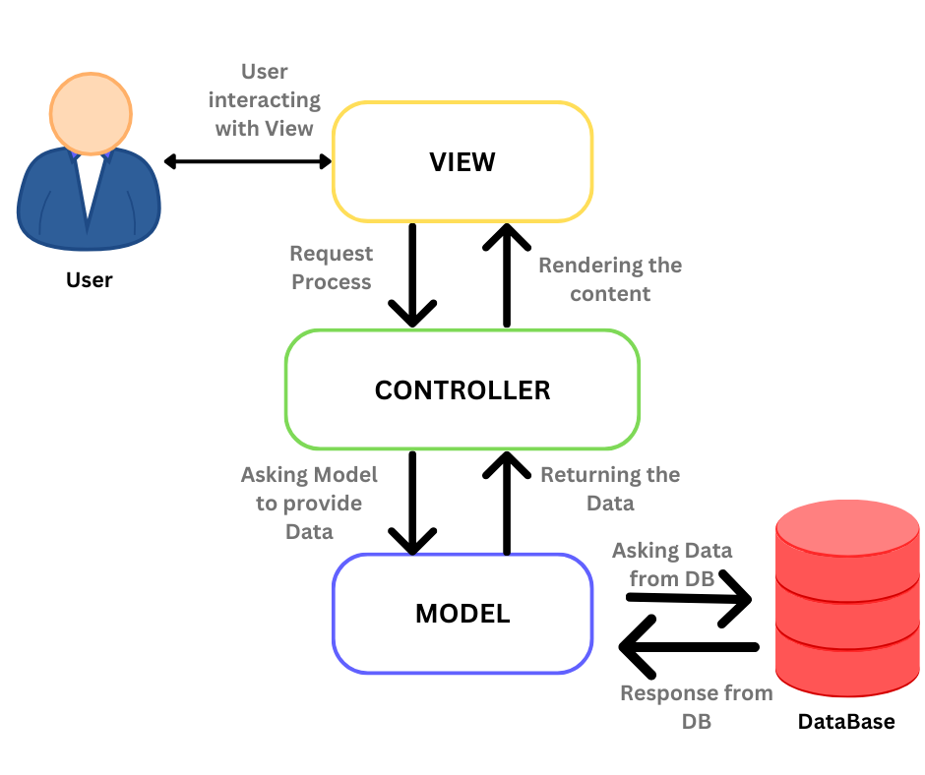

**Figure 1 MVC Architecture**

**Model**

* Represents the data and the business logic of the application.
* Encapsulates the data and provides methods to manipulate that data.
* Includes database interactions, data validation, and business rules.
* The Model notifies the Controller of any changes in the data.

**View**

* Presenting the data to the user.
* Represents the user interface (UI) components such as HTML pages, forms, and UI elements.
* Views receive data from the Model and display it to the user.
* In web applications, Views are often implemented using templates or markup languages like HTML, along with CSS for styling and JavaScript for interactivity.

**Controller**

* The Controller acts as an intermediary between the Model and the View.
* It receives input from the user via the View, processes that input by interacting with the Model, and then updates the View to reflect any changes in the data.
* Controllers handle user requests, invoke appropriate methods on the Model, and determine which View to render based on the requested action or route.
* In web applications, Controllers are often implemented as server-side components responsible for handling HTTP requests and responses.

## Iterative Method

Sampath Products is a developing and very small business. Therefore, the requirements and the business processes will be changed very frequently in it. So, the classical waterfall approach is not very suitable for this. Therefore, the approach which is used in here should be very flexible to change the given requirements as the client's needs.

That is the reason the iterative method is used for this project. In this method, the whole Software Development Life Cycle (SDLC) is divided into small chunks and doing it part by part.

Each part has mainly four (4) parts named as requirement gathering, Analysis and Design, Implementation, Testing and Evolution.

It is very flexible method to changing the project flow according to the changing of the client's requirements.

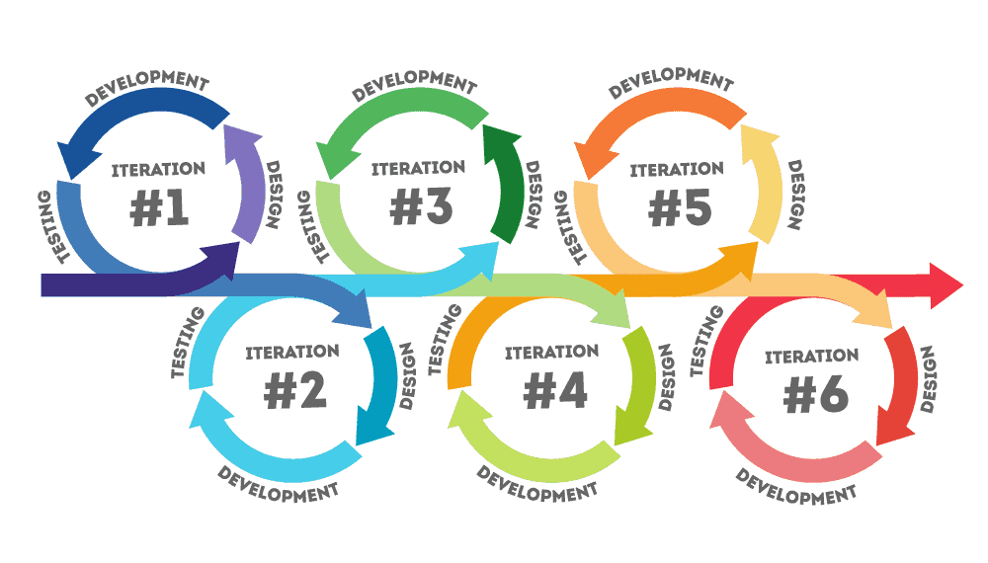

**Figure 2 Iterative Method**

For version controlling the Git was used and the version control is done with GitHub

## UML diagrams

UML diagram is called as the Unified Modeling Language is a great way to describe and model, what the system is going to do? How the system is working? There are many types of diagrams can be seen in UML diagrams.

For the designing purposes, few of those models can be drawn as following.

### Class diagram

Class diagram shows how the objects in this project is used and how they are created with the class. The relationships among those classes and their mapping also clearly can be shown through this.

Since, in this project, we use Spring Boot framework which is based on Java programming language, drawing the class diagram is essential thing because it is a Object Oriented Programming (OOP) Language. So, it is very important to have a good knowledge through this class diagram about the behavior of the classes.

Following diagram shows the class behavior and the objects those are defined in the system.

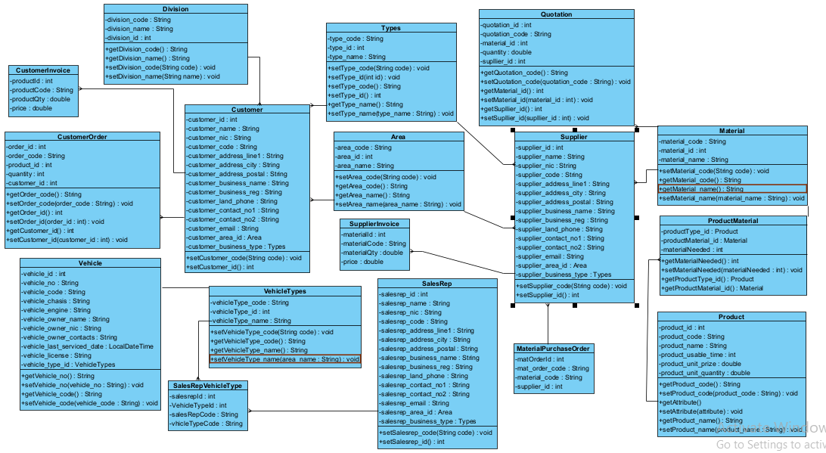

**Figure 3 Class diagram for Sampath Products**

### Sequence Diagram

Following Sequence diagram for show the Login module.

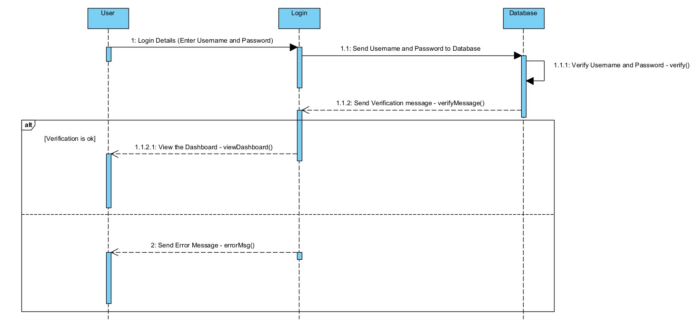

**Figure 4 Sequence Diagram for Sampath Products**

### Activity Diagram

Three diagrams below show the design of the processes of each sub systems.

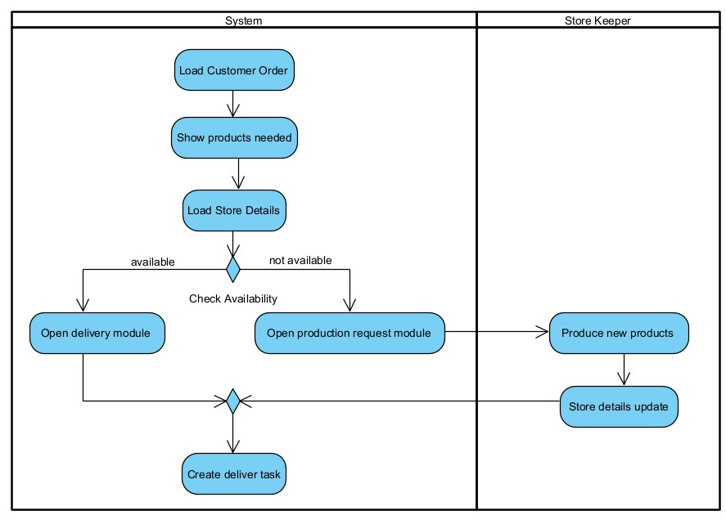

**Figure 5 Activity diagram Process Management Sub-system**

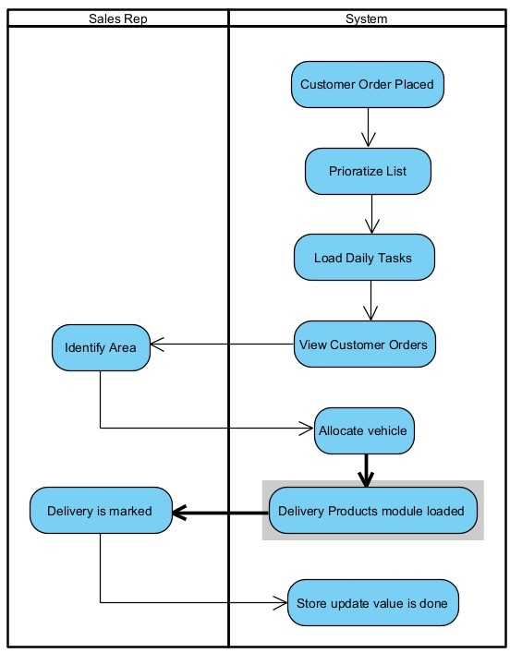

**Figure 6 Activity diagram Distribution and sales Management**

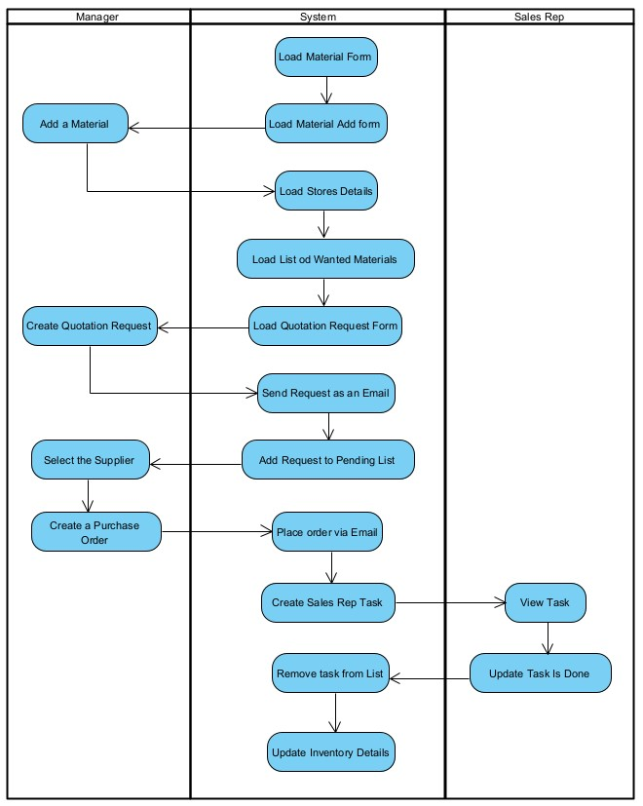

**Figure 7 Activity diagram Supply Management System**

### Use case diagram

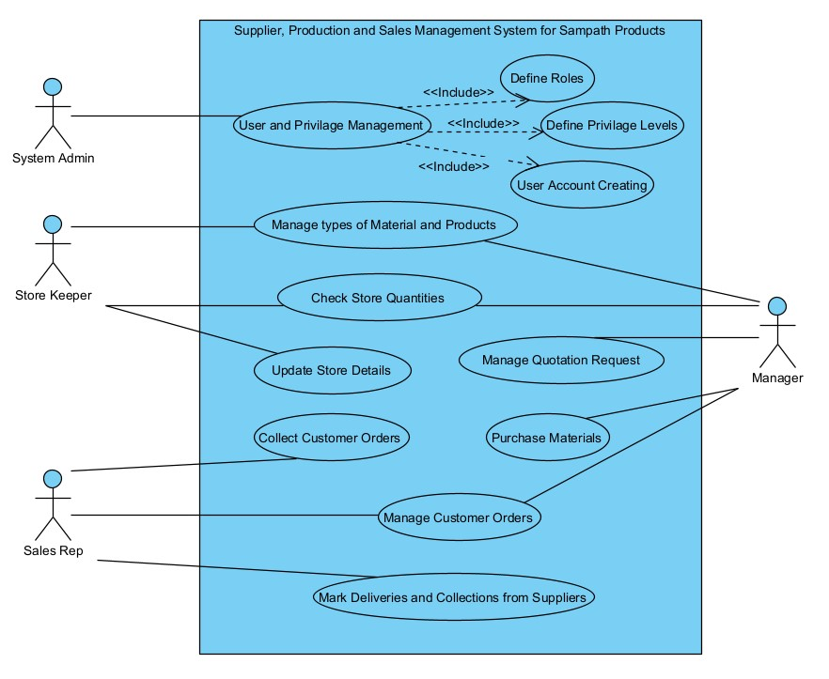These are roles for the Sampath Products and their responsibilities to regarding the system.

**Figure 8 Use Case Diagram for Sampath Products**

## Wire Frame Diagrams

These are some of Wire Frame diagrams of the system. The actual implemented view also there.

|  |
| --- |
|  |
| **Figure 9 Table View** |

|  |
| --- |
|  |
| **Figure 10 Context Menu** |

|  |
| --- |
|  |
| **Figure 11 Message Box** |

## ER Diagram

This is the ER diagram for Database creating.

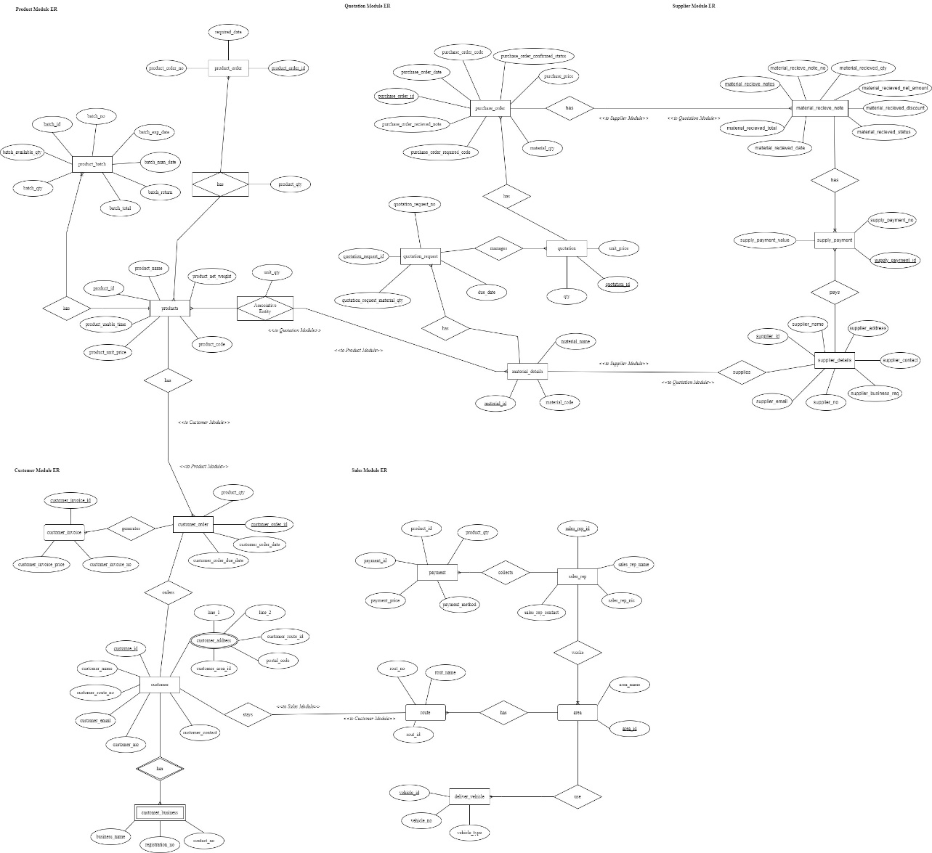

**Figure 12 ER diagram for Sampath Products**

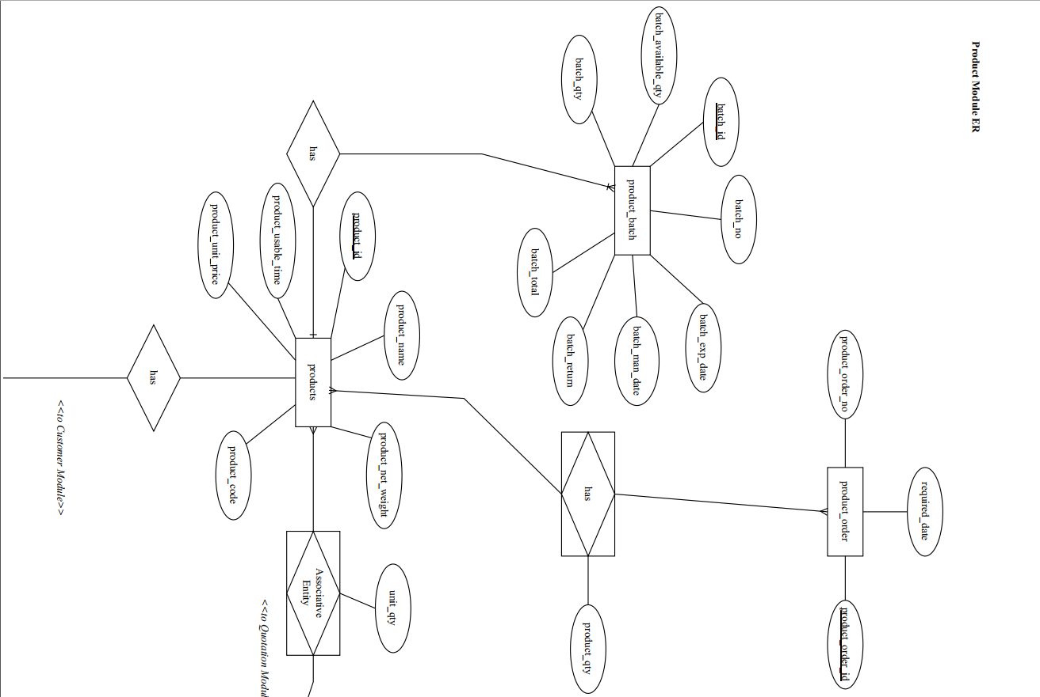

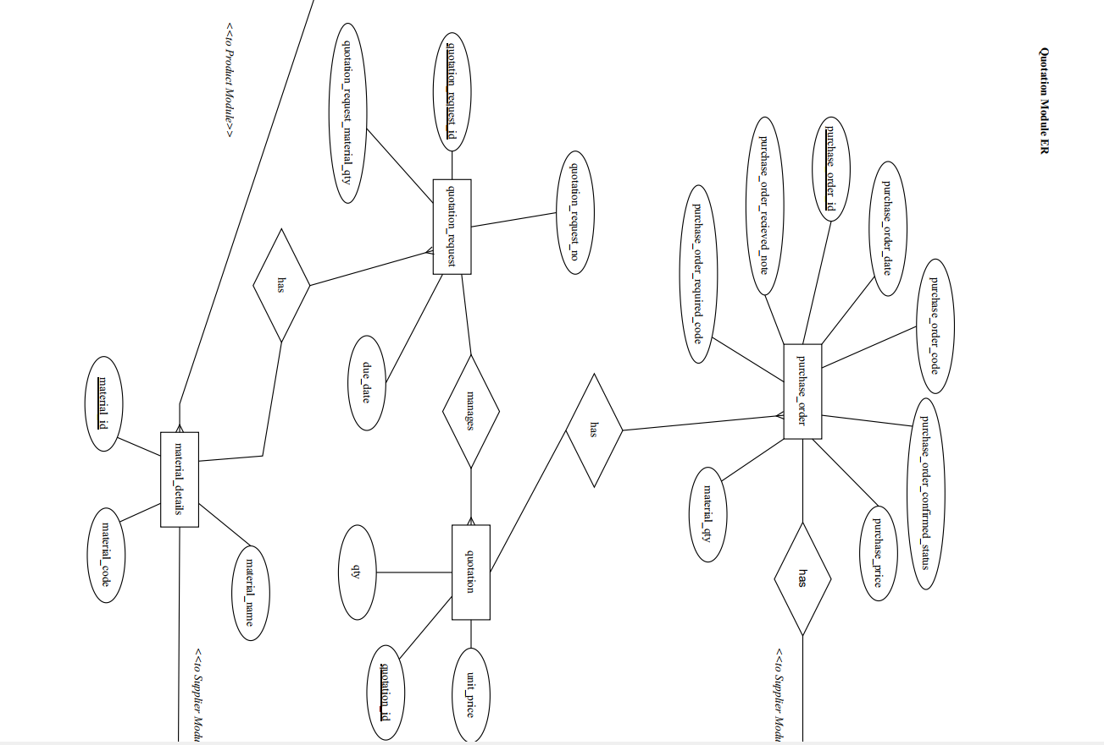

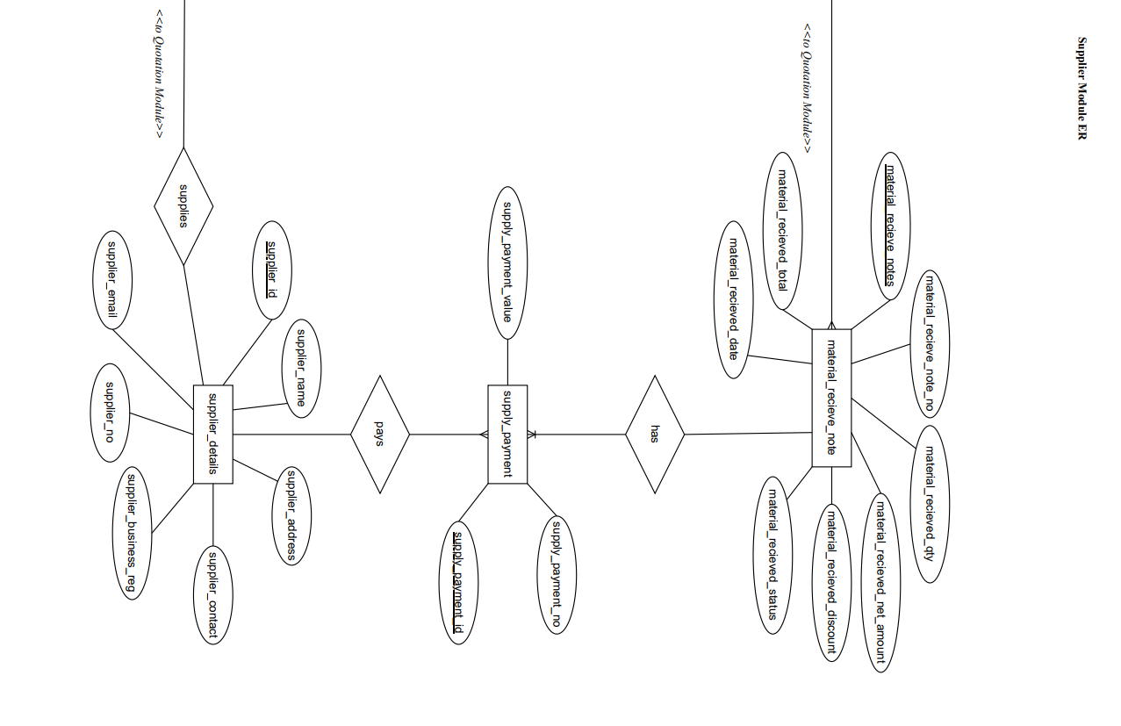

# 

# 

# Reference

*Agile Business Consortium*. (n.d.). Retrieved from https://www.agilebusiness.org/dsdm-project-framework/iterative-development.html

*Geeks for Geeks*. (n.d.). Retrieved from https://www.geeksforgeeks.org/mvc-framework-introduction/